**Unit 3 & Scanner cheat sheet**

**Boolean expression:**

== equals

!= not equals

*Return true or false values.

**Relational operators:**

< Less than

> Greater Than

<= Less than or equals to

>= Greater than or equals to

*Used only for numerical operations. Return true or false values.

**Conditional Statements:**

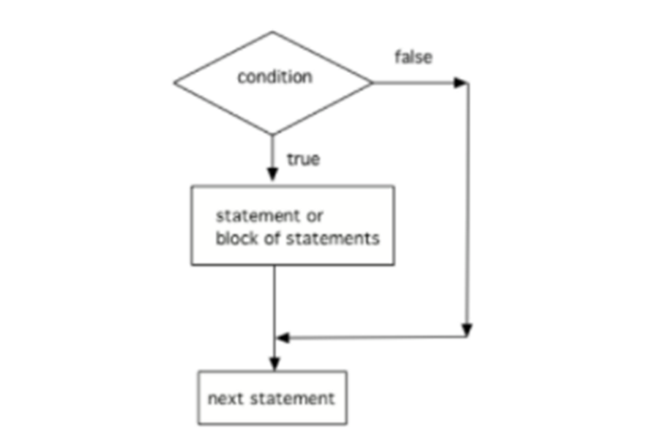

**if statement structure:**

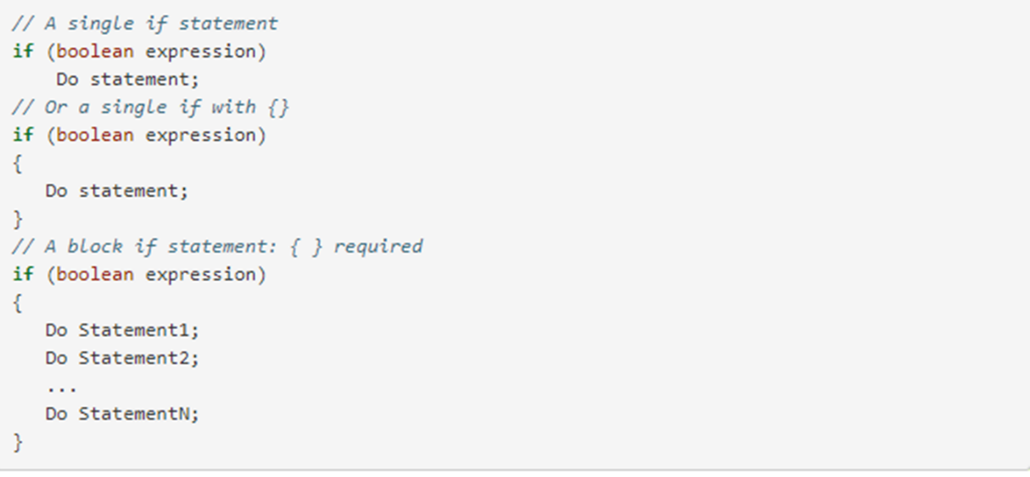

**if-else statement structure:**

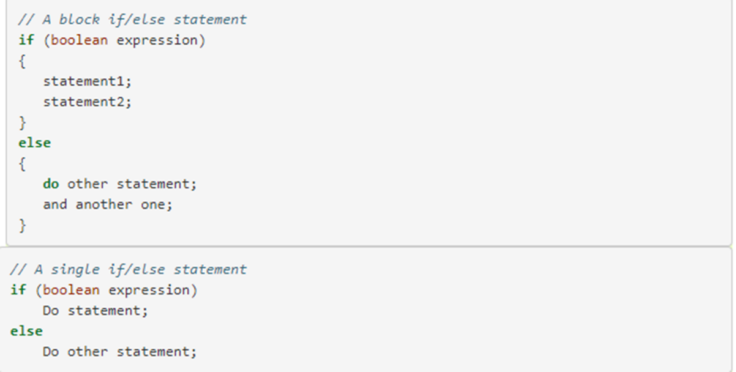

**else-if statement structure:**

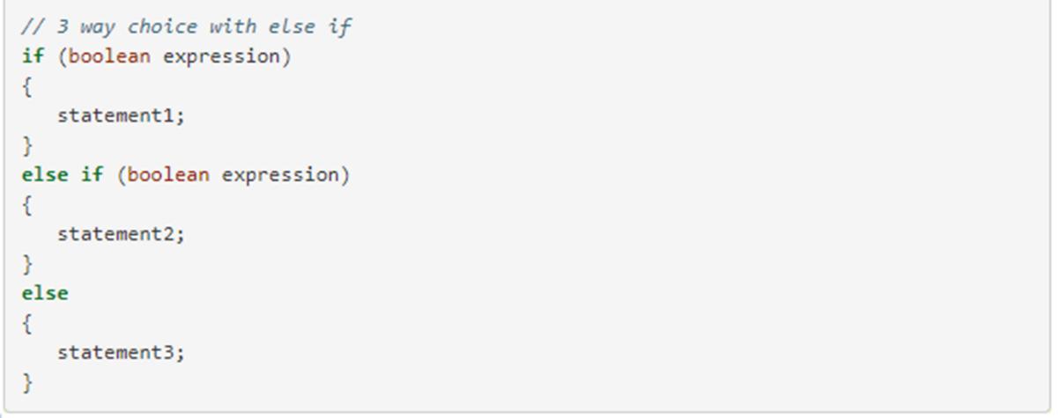

**Compound Boolean expressions:**

&& and – if you want two things to be true before the body of the conditional statement is executed.

|| or – if only one of the two conditions need to be true for the conditional statement to be executed.

! not – can be used to negate a Boolean value.

* In Java, ! has precedence (is executed before) && which has precedence over ||. Parentheses can be used to force the order of execution in a different way.

**De Morgan’s law:**

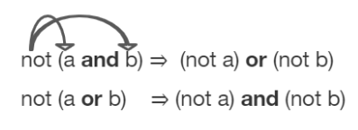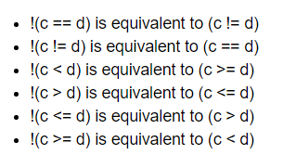

**Truth tables:**

*De Morgan’s law can be proved with a truth table.

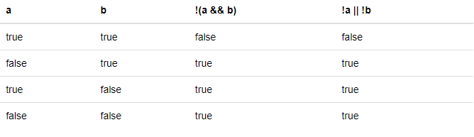

**Comparing Objects:**

* Often classes have their own equals method, which can be used to determine whether two objects of the class are equivalent.
* Two object references are considered aliases when they both reference the same object.
* Object reference values can be compared, using == and !=, to identify aliases.
* A reference value can be compared with null, using == or !=, to determine if the reference actually references an object.

**Scanner Class:**

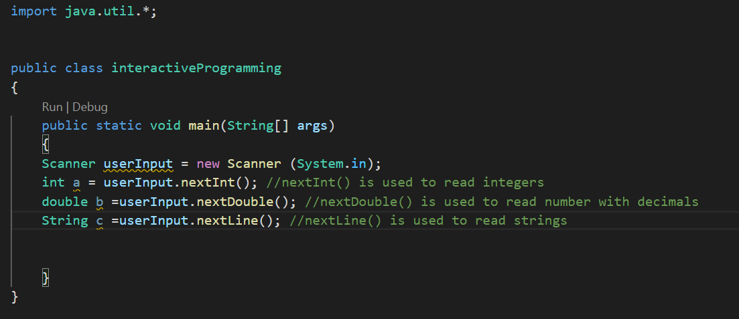

*for more about importing packages:

<https://www.w3schools.com/java/java_packages.asp>

*for more about the util package:

<https://docs.oracle.com/javase/8/docs/api/java/util/package-summary.html>

*for more about Scanner class:

<https://docs.oracle.com/javase/8/docs/api/java/util/Scanner.html>